Data Analytics (DA)

Module -2

Power BI Assignment 1 – Data Transformation & Data Modeling

1. Data Import:

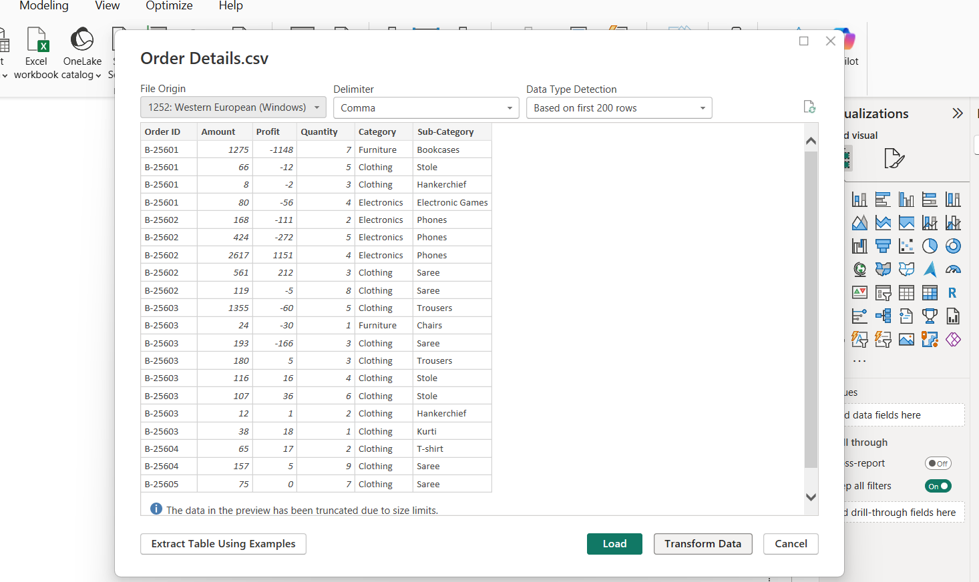

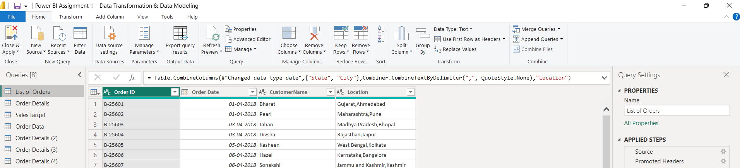

- Imported the data files into Power BI.
- Opened Power Query.
- Cleaned and transformed the data.

2. Row Limiting & Data Types:

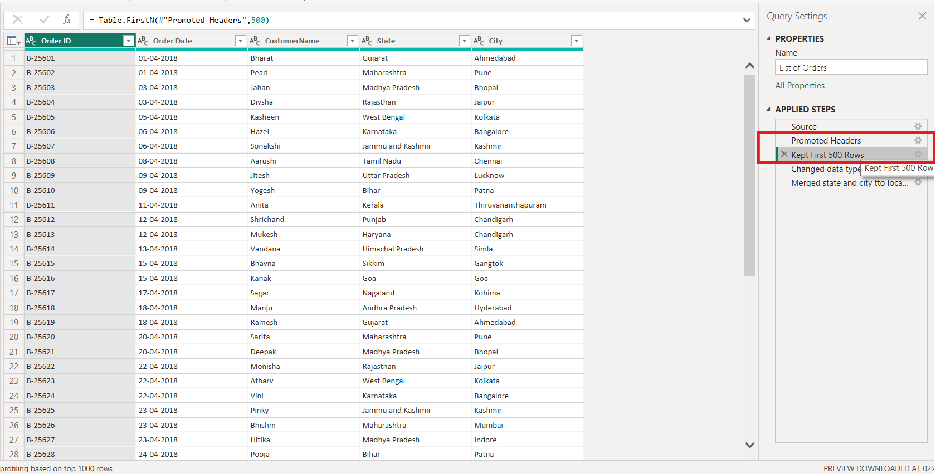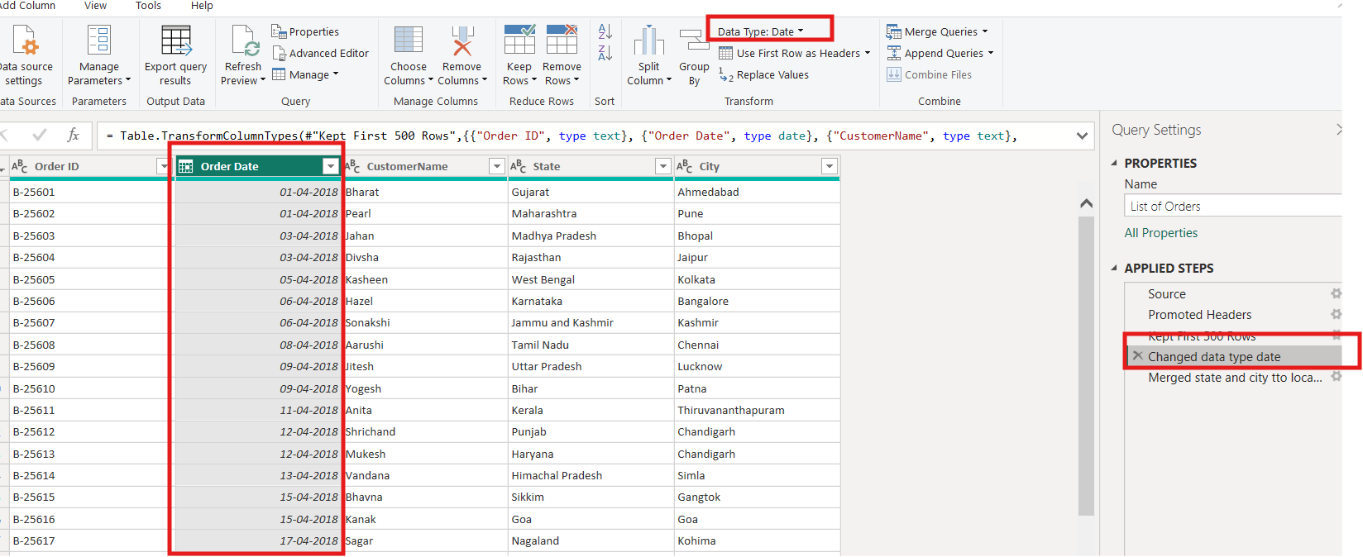
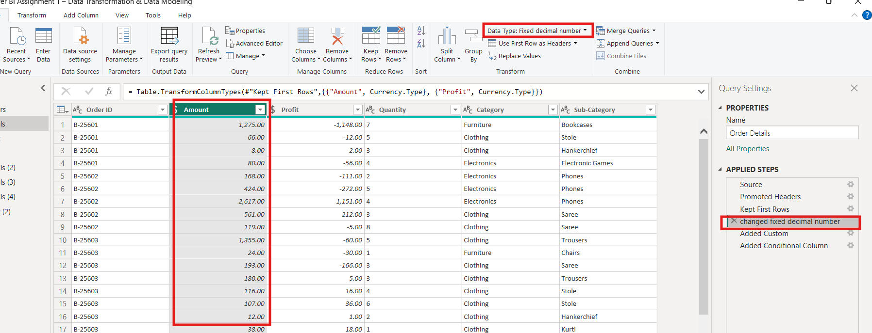

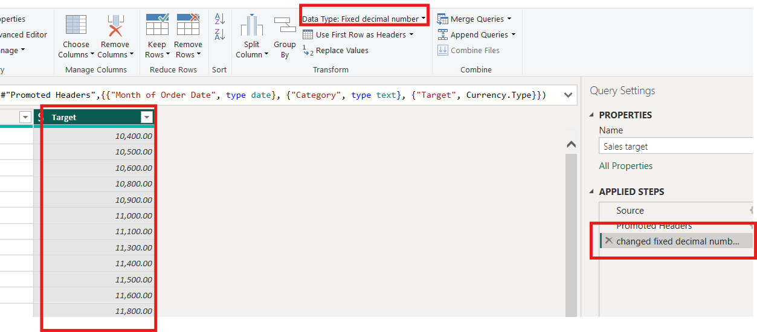

- Kept only the first 500 rows of the data.
- Changed the Date column to the Date data type.
- Changed the Amount and Target columns to the Fixed Decimal Number data type.

3. Text Formatting:
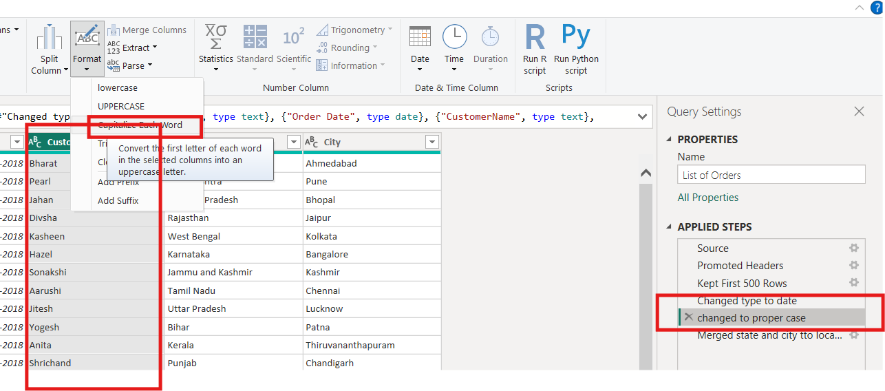

Here i changed to proper case

4. Column Creation:

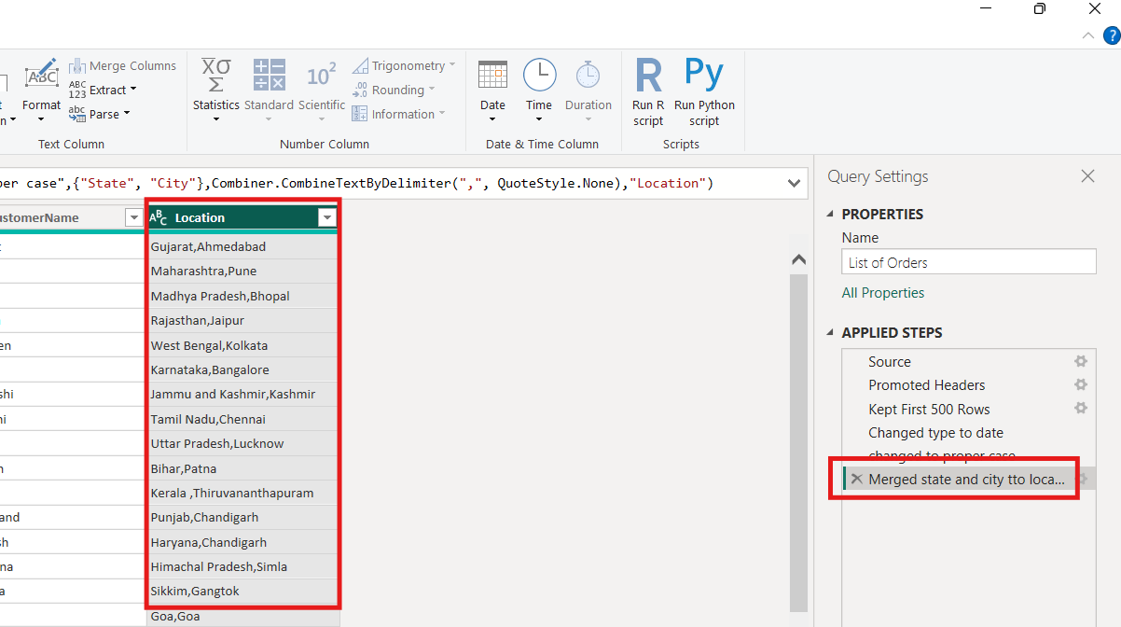
I merged the City and State columns to create a Location column.
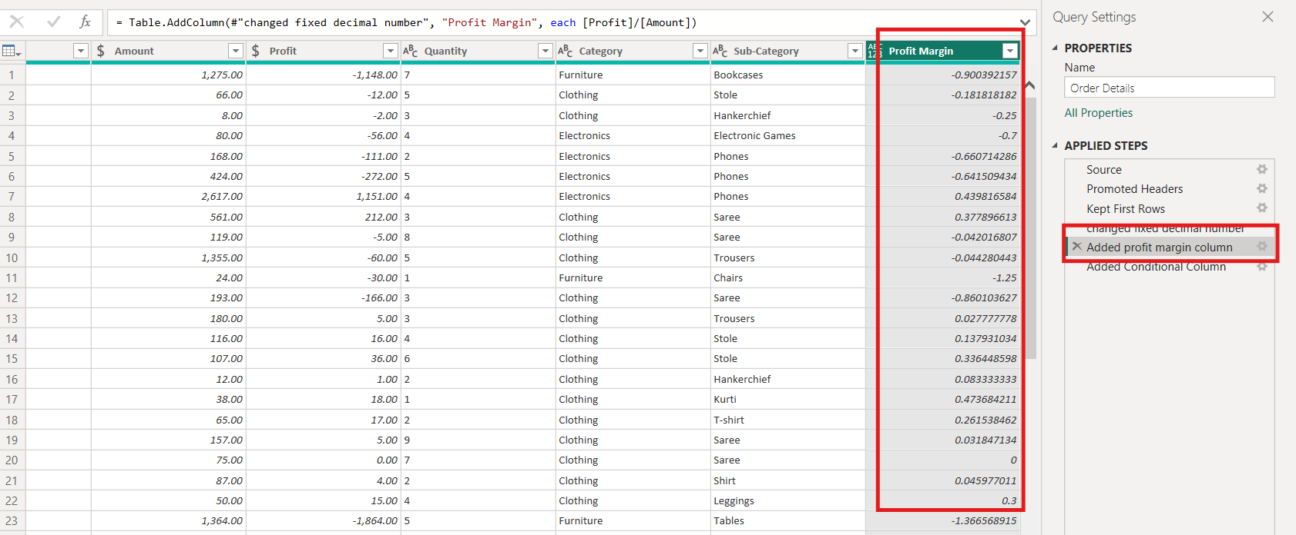

Created a custom column to calculate the Profit Margin.

5. Conditional Column:

■ Profit < 0 → Loss
■ Profit = 0 → Break-Even
■ Profit > 0 → Profit

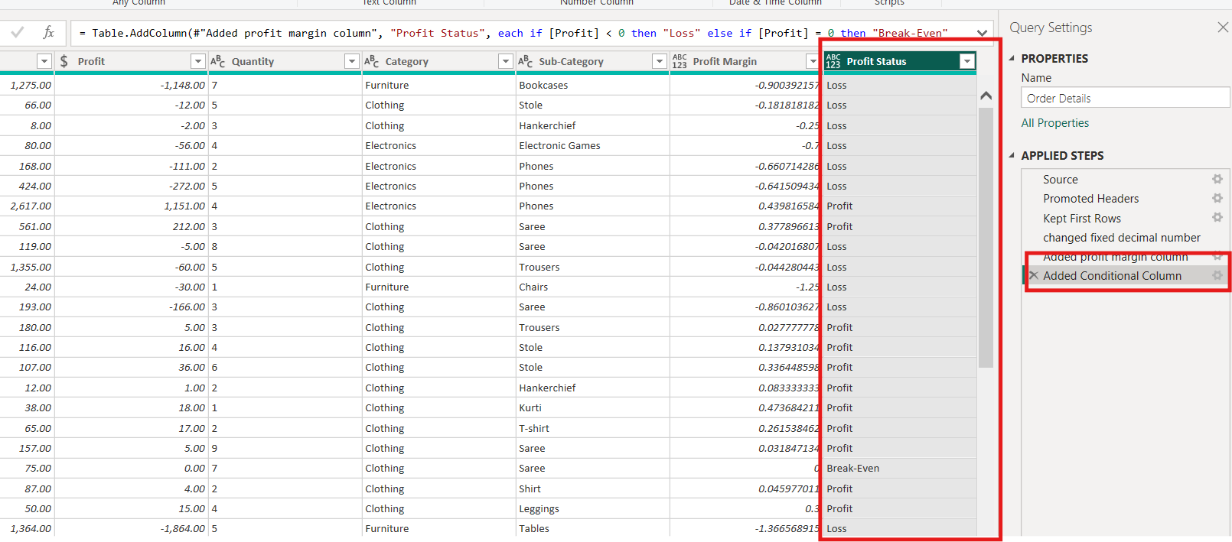
I created a Conditional Column to identify whether each record is Profit, Loss, or Break-even based on the profit value.

6. Merging Data (Joins)

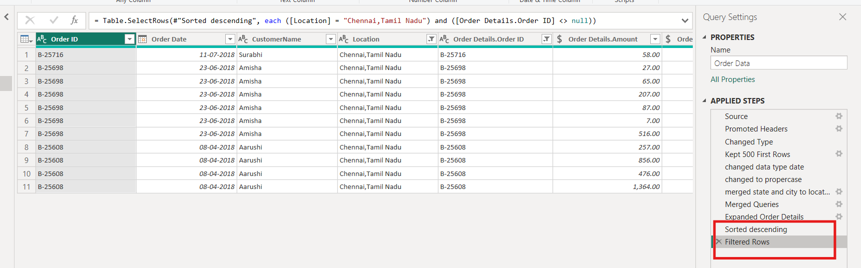

- Merged the List of Orders and Order Details tables.
- Used Order ID as the matching column.
- Named the merged table as Order Data.
7. Handling Missing Data & Duplicate Data
- Checked for missing values and found none.
- Checked for duplicate rows and kept them because they were valid.
8. Sorting and Filtering Data

Sorted the data in descending order.
Filtered the data to show only Tamil Nadu records

9. Grouping and Aggregating Data
○ Count of Order ID 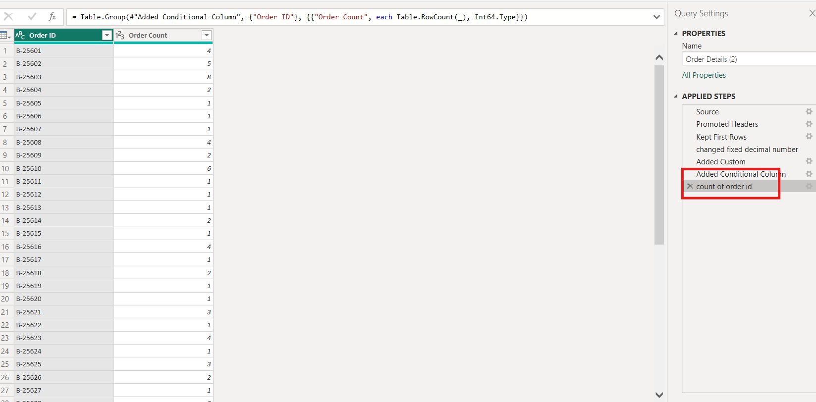
○ Average Profit by Category
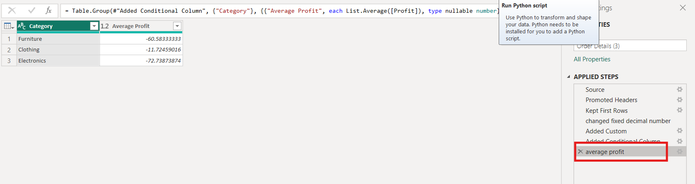

○ Total Amount by Sub-Category
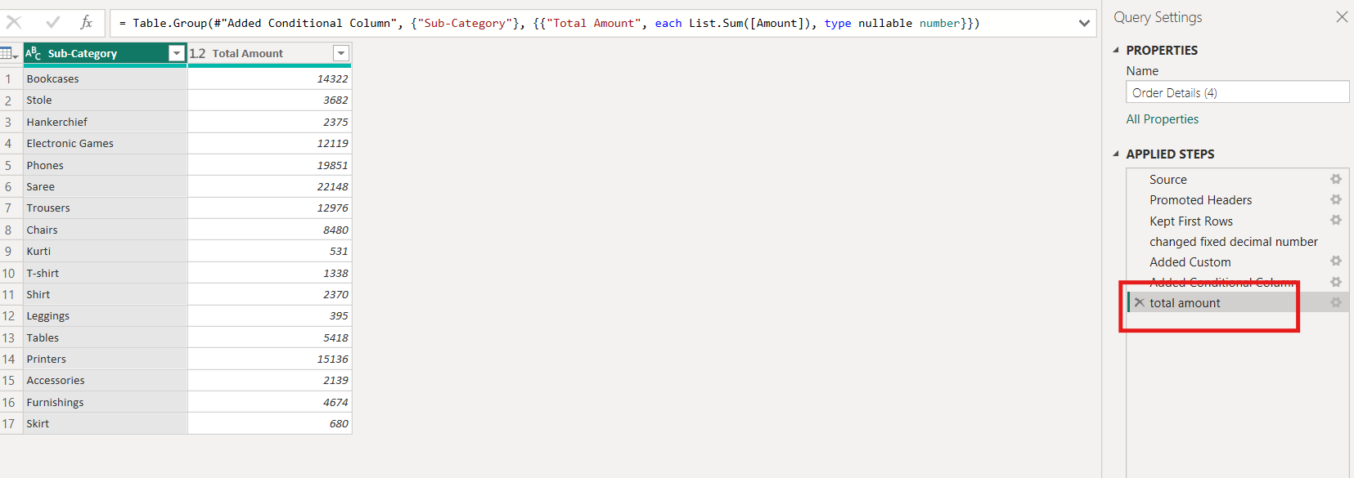

- Month of order date
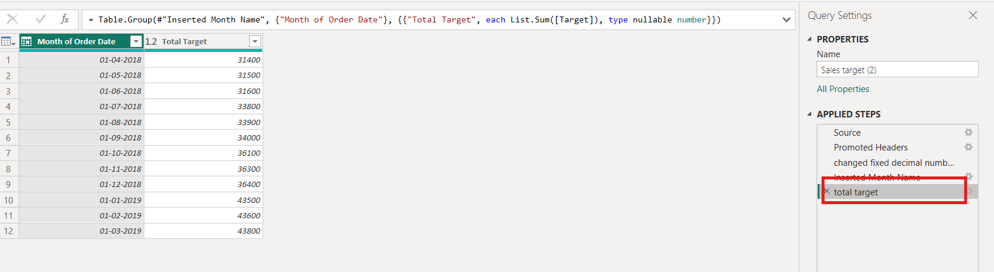

Used Group By to calculate the Count, Total, and Average.

10. Data Modeling:
